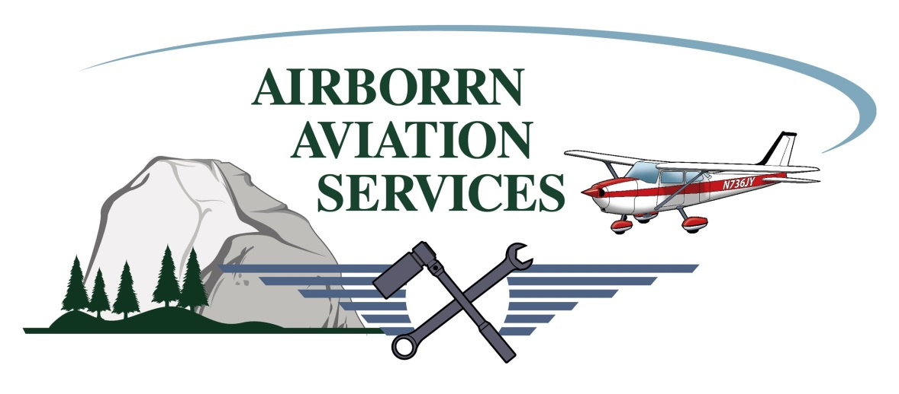

Private Pilot Flight Training Course (MCE)

(Minimum Requirements)
40 hours –Total
20 hours—Flight training
10 hours—Solo
3 hours—Flight training cross-country
5 hours—Solo cross-country
3 hours—Flight test prep
3 hours—Night
3 hours – Instrument training

40 Hours Aircraft - Cessna 172M

($2000.00 block purchase rate.)

Flight Training

20 hours dual flight training $3,600.00
20 hours solo flight $2,400.00 25 hours of pre-flight & post-flight ground instruction briefings $1,500.00
Basic training materials including online knowledge course $500.00
Written exam $150.00
FAA practical test–(check-ride) $600.00
_____________________________________________________________________________________
Total $8,750.00

Aircraft Rental = $120.00/hour. Ground/Flight Instructor (CFI) = $60.00/hour

NOTE: National Average for Private Pilot training is between 55-85 hours.

